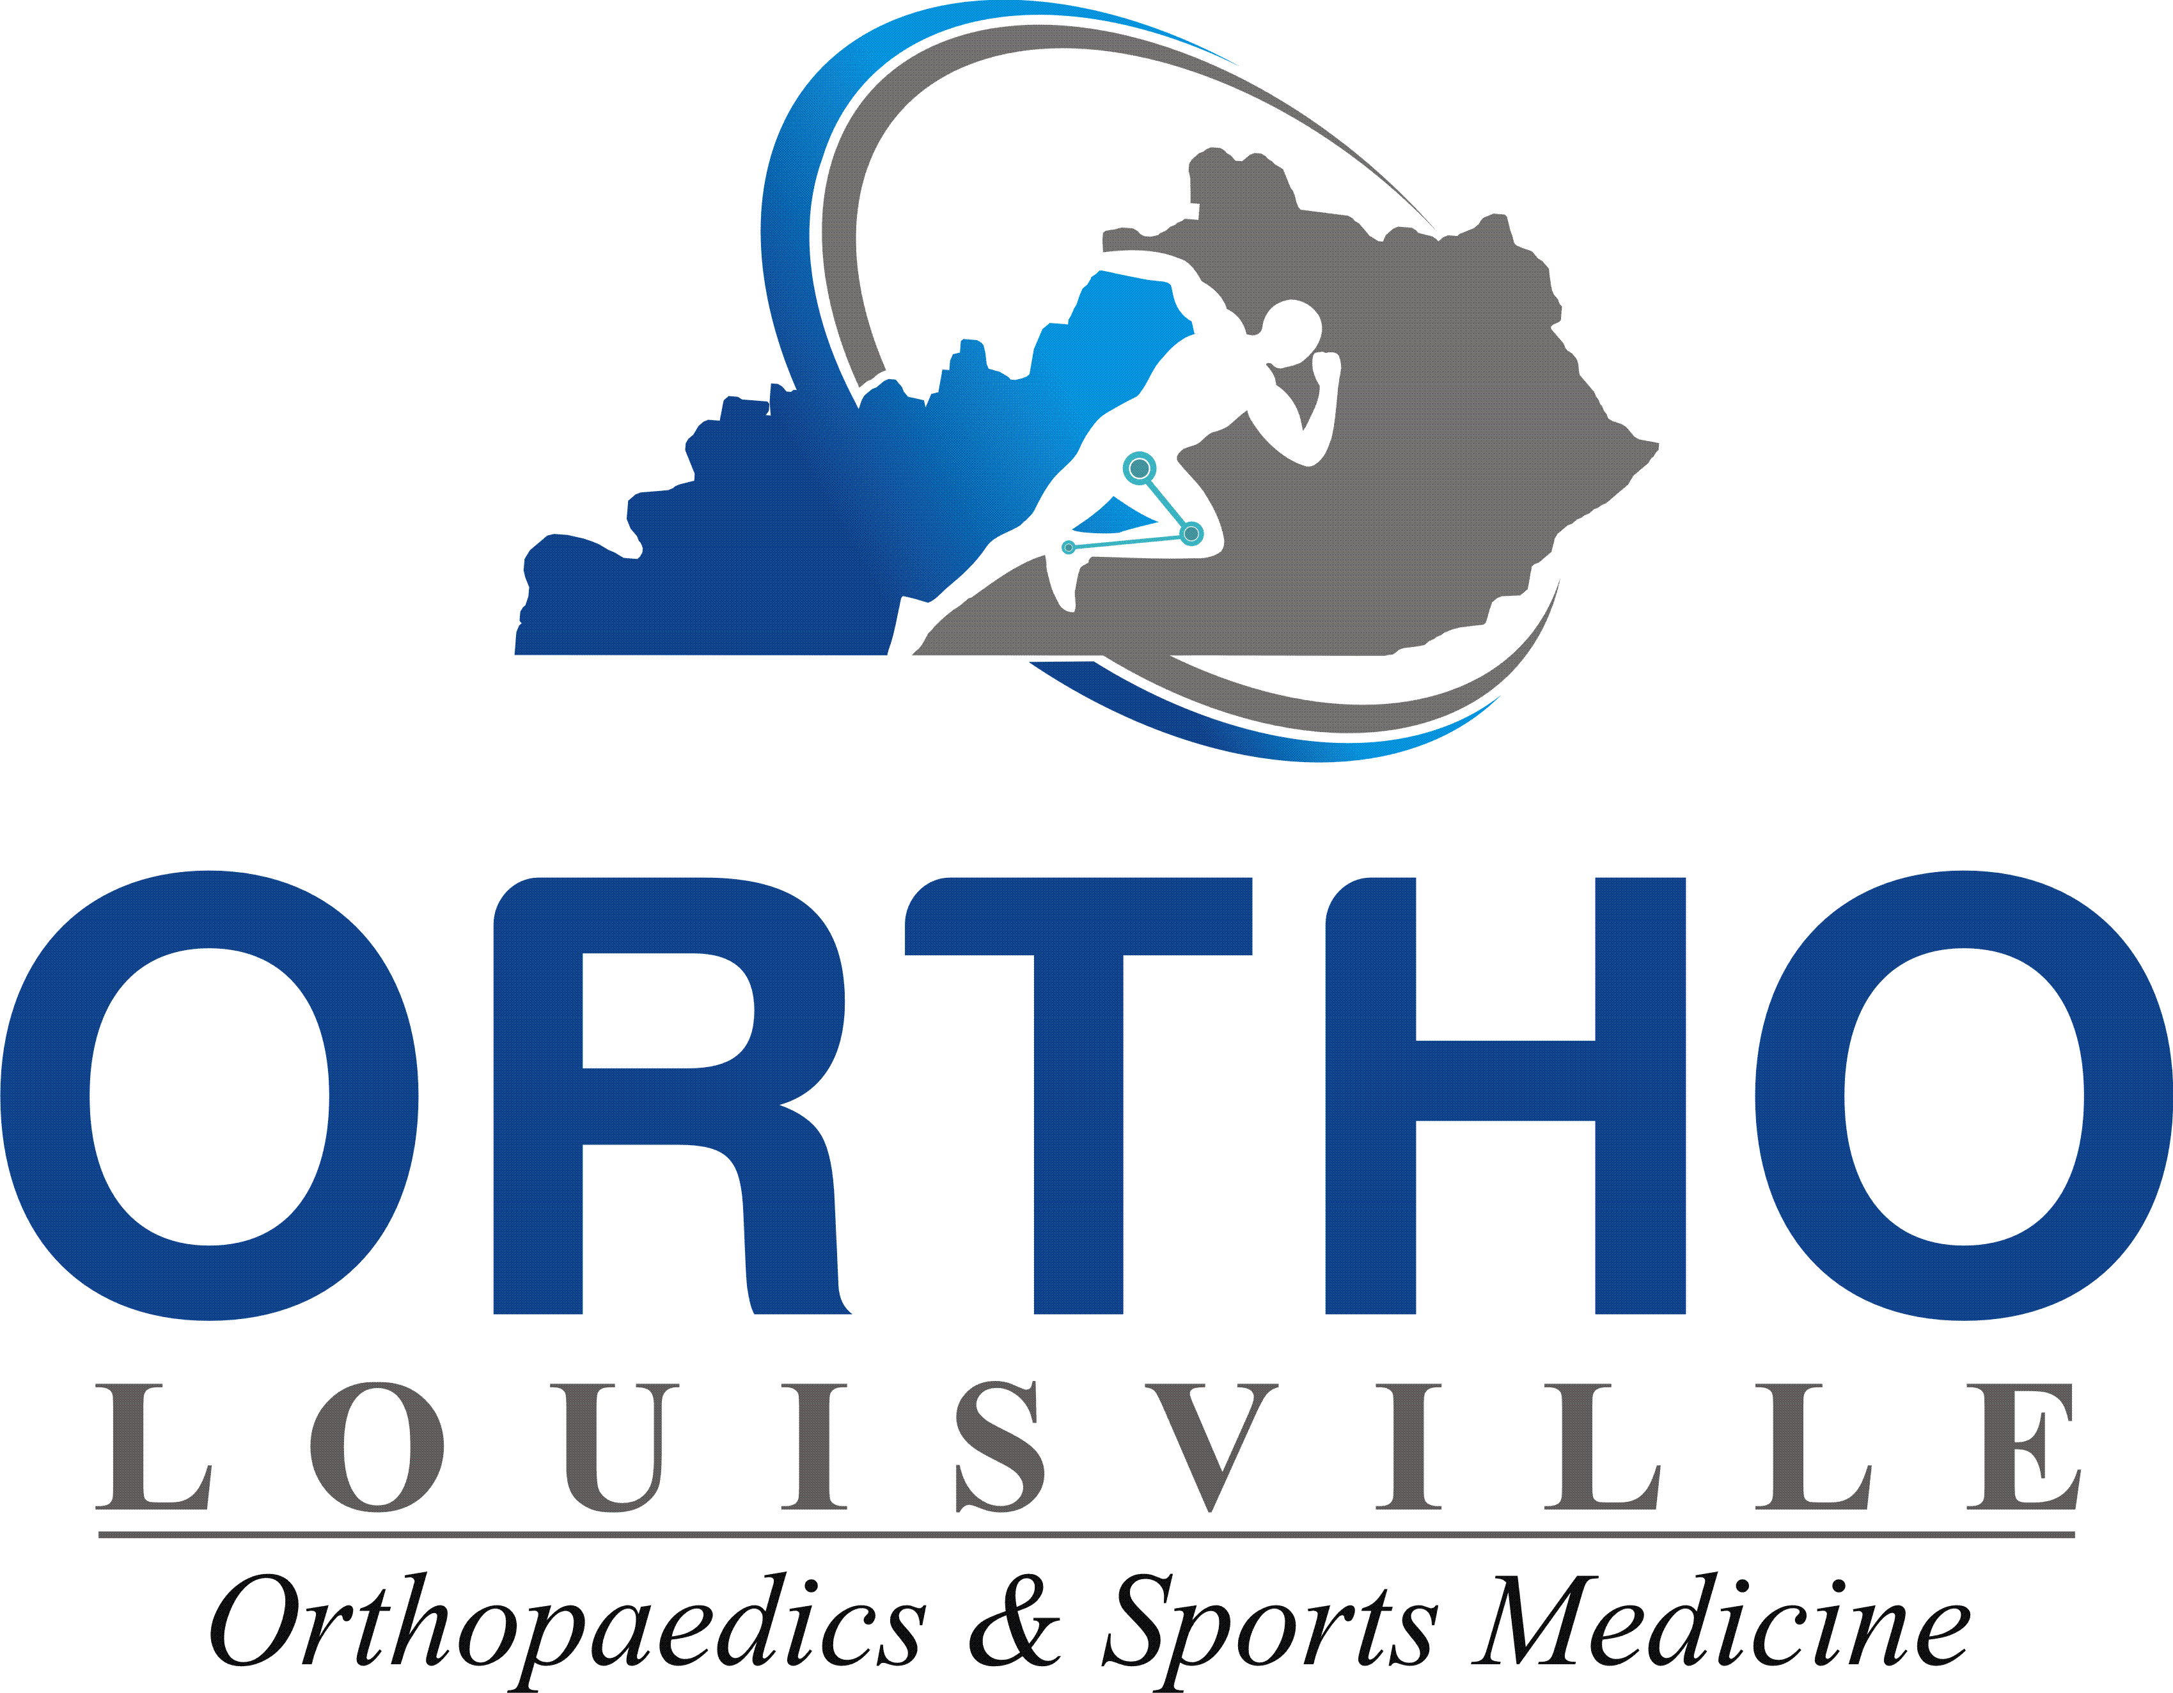
NOTICE INFORMING INDIVIDUALS ABOUT NONDISCRIMINATION AND ACCESSIBILITY REQUIREMENTS
Ortho Louisville, PLLC complies with applicable Federal civil rights laws and does not discriminate on the basis of race, color, national origin, age, disability, or sex. Ortho Louisville, PLLC does not exclude people or treat them differently because of race, color, national origin, age, disability, or sex.

Ortho Louisville, PLLC:
- Provides free aids and services to people with disabilities to communicate effectively with us, such as: o Qualified sign language interpreters
  - Written information in other formats (large print, audio, accessible electronic formats, other formats)
- Provides free language services to people whose primary language is not English, such as:
  - Qualified interpreters
  - Information written in other languages
- If you need these services, contact Amy Olson

If you believe that Ortho Louisville, PLLC has failed to provide these services or discriminated in another way on the basis of race, color, national origin, age, disability, or sex, you can file a grievance with: Amy Olson, Practice Manager, 8620 Biggin Hill, Louisville, KY 40220. Fax: 502-364-0099,
amy@prortho.net. You can file a grievance in person or by mail, fax, or email. If you need help filing a grievance, Amy Olson, Practice Manager is available to help you.

You can also file a civil rights complaint with the U.S. Department of Health and Human Services, Office for Civil Rights, electronically through the Office for Civil Rights Complaint Portal, available at https://ocrportal.hhs.gov/ocr/portal/lobby.jsf, or by mail or phone at:

U.S. Department of Health and Human Services 200 Independence Avenue, SW
Room 509F, HHH Building Washington, D.C. 20201
1-800-368-1019, 800-537-7697 (TDD)

Complaint forms are available at http://www.hhs.gov/ocr/office/file/index.html.

LIMITED ENGLISH PROFICIENCY OF LANGUAGE ASSISTANCE SERVICES
ATTENTION: If you speak English, language assistance services, free of charge, are available to you. Call l-502-364-0902 ext 101. ATENCION: si habla espaiiol, tiene a su disposici6n servicios gratuitos de asistencia lingiiistica. Llame al l-502-364-0902 ext 101.

ACHTUNG: Wenn Sie Deutsch sprechen, stehen Ihnen kostenlos sprachliche Hilfsdienstleistungen zur Verfilgung. Rufnummer: l-502-364-0902 ext 101. CHOY: Neu ban nui Tieng Vi t. cu cac djch vi; hu tn;, ngon ngil mifo phi dimh cho ban. G9i s6 1-502-364-0902 ext 101.

OBAVJESTENJE: Ako govorite srpsko-hrvatski, usluge jezicke pomoci dostupne su vam besplatno. Nazovite 1-502-364-0902 ext 101.

ATTENTION: Si vous parlez fram;ais, des services d'aide li.nguistique vous sont proposes gratuitement. Appelez le 1-502-364-0902 ext 101.

Wann du [Deitsch (Pennsylvania German/ Dutch)] schwetzscht, kannscht du mitaus Koschte ebber gricke, ass dihr helft mil die englisch Schprooch. Ruf selli Nummer uff: Call 1-502-364-0902 ext 101.
=

Ulr.! : :!TT'IT :mrr= f.1-c\R"I> l<'l1TT \J,' I 'liTi'I 1-502-364-0902 ext 101 I
XIYYEEFFANNAA: Afaan dubbattu Oroomiffa, tajaajila gargaarsa afaanii, kanfaltiidhaan ala, ni argama. Bilbilaa 1-502-364-0902 ext 101. BHl1MAHl1E: Ecm,1 Bbl roaop1.ne Ha pyccKoM ll3bIKe, TO aaM A0CTYTIHbI 6ecnnaTHb1e ycnyrn nepeB0Aa, 300H11Te 1-502-364-0902 ext 101. PAUNAWA: Kung nagsasalita ka ng Tagalog, rnaaari kang gumamit ng mga serbisyo ng tulong sa wika nang walang bayad. Turnawag sa l-502-364-0902 ext 101. ICITONDERWA: Nimba uvuga Ikirundi, uzohabwa serivisi zo gufasha mu ndimi, ku buntu. Woterefona 1-502-364-0902 ext 101.

